**Blockchain Storage:**

**Definition:**

* It is the way of **saving data in a decentralized network**, which **uses the unused space of users across the world.**
* It is an **alternative to centralized cloud storage**. And it can **solve many problems found in centralized cloud storage.**

**How it works:**

* Blockchain **relies on the DLT** -> Distribute Ledger Technology which **acts as a decentralized database of information about transactions between various parties.**
* Operations/transactions fill in DLT **in chronological order and** are stored in the ledger as **a series of blocks**. Here each block refers to the previous block that creates the blockchain.
* In blockchain storage, **files are broken apart called sharding**. Each **shard is copied** to prevent loss of data and **encrypted with a private key** that makes it impossible to view by other nodes in the network.
* The replicated/**copied shards are shared among nodes** available over the decentralized network. The interactions are recorded in the blockchain ledger/network, allowing to **confirm and synchronize the transactions across the nodes in the blockchain**.
* Blockchain storage is designed to save all these interactions forever and **data can never be changed.**

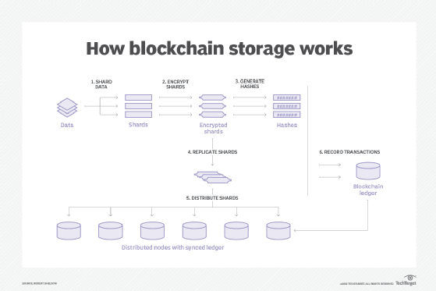

**Blockchain vs Cloud storage:**

* Blockchain is potentially **cheaper, more secure, and reliable than cloud storage**.
* In Cloud storage, to prevent data loss providers make copies of data and store it in multiple data centers. This will create an excessive of surplus information. Also, the data center needs enterprise-grade hardware. This makes centralized cloud storage more expensive.
* Blockchain **uses the unused spaces of users to save transactions which can cut 90% of cost of centralized cloud storage**. Also, it can **benefit both individuals and businesses by renting unused hard disk space for others to use**.
* In blockchain, **encrypting file**s and distributing them among the network, will make it **harder for hackers to access the data**. Also, no central authority to control and proposing private keys to decrypt the files.
* The **private keys are controlled by the users only**, it will be harder for third parties to access the files.
* **Sharding also provides security and privacy**.
* Blockchain storage could also **allow faster and more customizable storage systems** because [users are able to manipulate settings](https://www.techtarget.com/searchcio/feature/Todays-blockchain-use-cases-and-industry-applications), such as the speed of retrieval and redundancy.

**Example blockchain storage projects:**

* ***BitTorrent, FileCoin, Sia and Storj***

**BitTorrent:**

* It is based on its **file-sharing protocol (BTFS) and Tron's decentralized blockchain platform**. The network lets storage **"renters" pay "hosts" for their excess capacity.**

**FileCoin:**

* It uses blockchain and the **InterPlanetary File System (IPFS**) to let **users purchase storage** from providers on the network.
* **IPFS is a peer-to-peer (**[**P2P**](https://www.techtarget.com/searchnetworking/definition/peer-to-peer)**) hypermedia distribution system** designed **to provide a decentralized method for storing and sharing files**.
* Nodes within the IPFS network form a distributed file system that can be accessed in many ways, including the Linux-based FUSE interface and [HTTP (Hypertext Transfer Protocol)](https://www.techtarget.com/whatis/definition/HTTP-Hypertext-Transfer-Protocol). Local files can be added to the IPFS network and made available to the world.

**Sia:**

It is a decentralized storage marketplace built on **open source software developed by the SIA** Foundation. The platform lets **renters enter contracts with hosts that offer their excess storage**.

Storj:

* It is based on the **Ethereum blockchain platform**, aims to **provide private, secure and efficient P2P-based cloud storage.**
* The Storj platform uses sharding and end-to-end encryption ([E2EE](https://www.techtarget.com/searchsecurity/definition/end-to-end-encryption-E2EE)) to store and protect data.